Plato’s ideal state

*Laure Dijkstra (*[*lauredijkstra@live.nl*](mailto:lauredijkstra@live.nl)*).*

*1 atheneum tto*

*De opdracht betreft de onderstaande inhoud (zie ook de Powerpoint). Ik heb tijdens de uitleg een slide met de stappen van de opdracht en tijdens de opdracht heb ik de drie zielselementen en de drie maatschappelijke groepen geprojecteerd. Leerlingen krijgen een handout met de instructies (pagina twee). Ik heb deze les in veertig minuten gegeven, maar hij komt beter tot z’n recht in vijftig minuten. Antwoorden staan op pagina vier.*

In this lesson, students have learned the definition of philosophy, multiple subjects of philosophy and elements of Plato’s philosophy. Students have first learned that a human consists of three parts namely:

1. **Appetite** or hunger 🡪 seek for enjoyment
2. **Spirit** or emotions 🡪 seek for challenges
3. **Logic** or rational thinking 🡪 seek for wisdom.

Plato also had ideas about the ideal state and opposed democracy. He identified three groups in a society:

1. Philosopher kings
2. Soldiers
3. Workers

Students will draw a human body and first place the elements into body parts. Then they will connect the three groups in society to the three elements of a body. So the goal is that they will understand that the philosopher kings correspond with both logic and therefore with the head. A guiding question could be: do soldiers seek challenges or enjoyment?

The assignment will be discussed in the class and after the correct answers by Plato have been discussed, we will underscore that the human body is a metaphor for the ideal state according to Plato. Additionally, we will discuss whether there is a hierarchy and what we think of the workers being categorised as the appetite and seeking for enjoyment.

Plato’s ideal state: assignment

Work with your neighbour in English. Talk quietly, raise your hand to ask questions or ask them quietly to a classmate.

* Draw a human body and place the three parts of the human into body parts.
  + So where would spirit be in the human body?
* Match the three parts of the state to the human body parts.
  + With what would you match the workers?
* Answer the following questions in your notebook after you’ve discussed them with your neighbour.

1. Why do you think Plato matched the three groups of the state to the three parts of a human?
2. Why would this be an ideal state for Plato?
3. Do you agree that this is an ideal state? Why?
4. Do you think Plato thought all groups were equally good? So was there a hierarchy?
5. Could you match the Dutch state to this body?
6. Discuss with your neighbour what you think of Plato’s philosophy about humans and the state by asking each other questions. If you think you are finished with Plato, talk about the other subjects of philosophy. Write the questions that you’ve asked down and show them before you leave class.

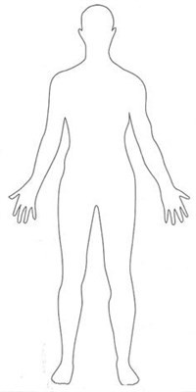

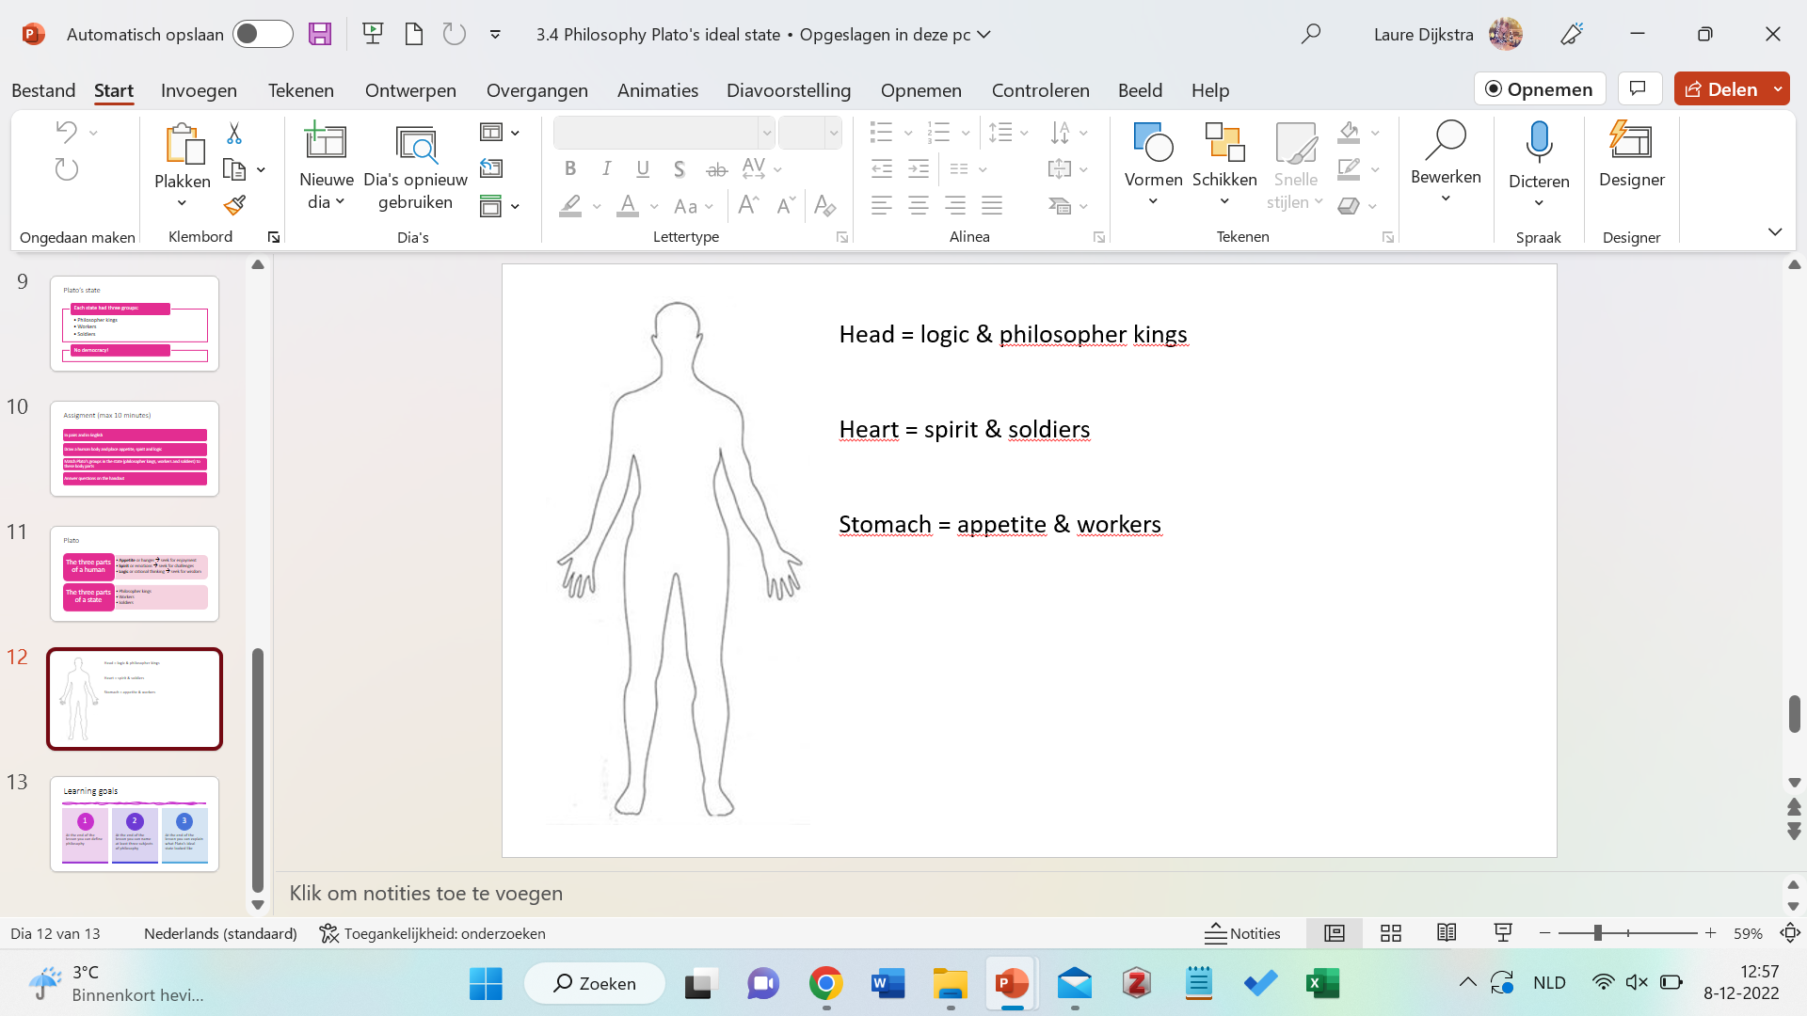Answers